Reflective report:

By Yiwen Huang

Method

There are two methods to carry out the protocol design, and the difference between the two methods is whether the data achieve reliability first. From the picture below, the method to achieve reliability first has been chosen due to the accuracy of this method. Meanwhile, the ICNS is used as data link layer in this protocol design.

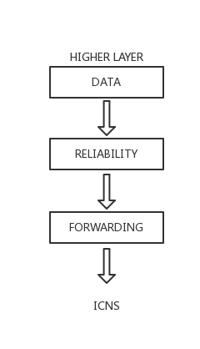

Timeout

The timeout rule should be set to carry out retransmission after a period time without acknowledgement, which is to cure the losing messages in underlying service. The duration of timeout is quite an important point in this design, because if duration of timeout is too short that will lead to duplication of messages, however, if duration of timeout is too long that will bring other problems, such as retarding the speed of transmission. Thus, the design of timeout is a key point, which will influence the accuracy of whole transmission.

Corruption control

The traditional mechanism to control the corrupt error is to use checksum or error-detecting code. The general principle of corruption control is that correct blocks satisfy a certain standard, however, the corrupt blocks do not satisfy this. It can help protocol to distinguish correct blocks from corrupt blocks, but the accuracy of filter still relies on the complexity of the standard.

Header

From the picture below, it can be seen that the header of packet contains essential information for transmission. The flag also contains acknowledgement and other several important information.

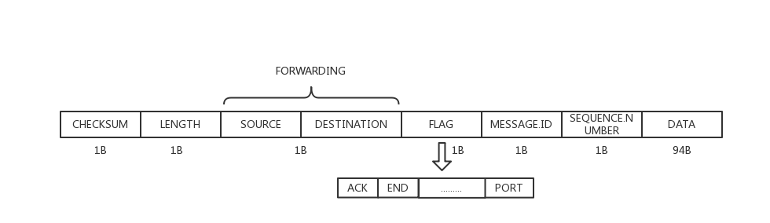

Broadcast

Broadcast means that one host send a message to everyone, which need forwarding to access the hosts that are not the neighbors of the sender. However, there is a risk for using broadcast when a host uses broadcast to send message bring acknowledgement back to source, then it may be form a loop between several hosts.

Broadcast routing and multicast routing

Broadcast routing relies on link-state and it equals to n-way-unicast, and in fact, it is a way to control flooding that each node maintains a list of source address, and use sequence number also help to control flooding. To avoid flooding, the mechanism to check source id for not sending message back to source should be set, and to hold a record after receive messages for only forward once is also important. Each multicast packet and sequence number of each broadcast packet will carry the IP address of all of the multiple recipients.

Dynamic routing

In dynamic routing, every router knows information from immediate neighbors. And, if there is a new node joining the routing, it should be added in the routing table. Otherwise, every router knows the cost between immediate neighbor and itself, so every router will choose the minimum cost way to transfer the messages. Thus, when routing table is changed every router should tell neighbors to update their routing table.

Notes

There are also several notes in design, one is that file name should be less than 94bytes in data link layer packet, and another one is that sequence number 0 is always file name in this design.

Possible enhancement

Dynamic routing and file transfer are two possible enhancement, however, there are some problems in carrying out. And low feasibility of broadcast also obstructs achievement of dynamic routing and file transfer.

Reference:

Robin, S. (1994) Principles of protocol design, London: Prentice Hall Press.